Project Report (Fall-2025)

Organization of Computer & Assembly Language

(EL-2003)

Project Title: Brick Breaker Game

Date Of Submission: 22nd November 2025

Group Members:
Syeda Maha Fatima (24K-0624)
Fabiha Siddique (24K-1022)
Iqra (24K-1024)

Summary:

Our Project “Brick Breaker Game” is a console-based implementation of x86 Assembly Language using MASM and Irvine32. Its purpose was to successfully implement the logic behind the original Brick Breaker Game using the core concepts of low-level programming.
Built from scratch, it includes input handling, console manipulation, sound integration, game loop controlling, usage of registers and much more.
Key Features: The game features a main menu, difficulty levels, level upgrading and a scoring system.

Introduction:
- Background:
This project is highly related to COAL as it is solely based on low-level programming and while building it, we used the following concepts:

- Register Manipulation
- Knowledge of Stack & Memory
- Handling Input/Output at low-level
- Programming in Assembly Language (x86)
- Handling Errors & Exceptions

- Objectives:
We successfully achieved the goals mentioned in our proposal which were:

- Memory management: Includes stack, registers.
- Input/Output Handling: Required understanding of low-level programming.
- Efficient Game Loop Control: Using loops, jump conditions, cmp operator and counter registers etc.

Project Description:
- Scope:
We included various features in our game which include:

- Ball Movement
- Controlled Paddle Movement
- Collisions
- Difficulty Modes (Easy, Medium, Hard)
- 3 Levels with increasing breaking powers (HP) of bricks.
- Scoring
- Bonus Life on reaching to level3
- Game Over & Main-Menu Screen
- Sounds like collisions, navigation, losing lives, level up and game over.

Still there are some features excluded such as:

- Save/Load Feature
- Online players
- More than 3 levels.

- Technical Overview:
The tools and technologies used in our project are:

Language: x86Assembly Language
Software: Visual Studio 2022 + Windows Console
Assembler: MASM
Libraries: Irvine32, Macros and Winmm (for sound)

Methodology:
- Approach:
Almost, it took us 2weeks for project completion.

Day1-2: Built Welcome Screen & Main Menu.
Day3-4: Drawing Bricks & Paddle
Day5-7: Collision Logic
Day8-9: Added Difficulty Modes & Some Error Handling
Day10-12: Added 3 Levels
Day13-14: Sound Integration & Final Enhancements

- Roles & Responsibilities:

- Syeda Maha Fatima: Sounds & Color Graphics
- Fabiha Siddiqui: Main Menu & Other Screens
- Iqra: Core Logic

Project Implementation:

- Design & Structure:

- Loading Screen
- Welcome Screen (Asks for player name)
- Main Menu (Includes Start Game, Instructions, High Score & Exit)
- Start Game (Asks for choosing between Easy, Medium & Hard)
- Main Game (Level-up if all bricks destroyed, else game over appears)
- Winner Screen (If wins the game)
- Game Over Screen
- Either Exit or Back to Main Menu
& the loop continues.

- Functionalities:

The following primary functions have been implemented:

- DrawPaddle (Draws paddle)
- ErasePaddle ( Erases paddle)
- DrawBox (Used to draw the box for each screen)
- Screen1 (Handles the welcome screen & entire main menu under one procedure)
- DrawBall (Draws Ball)
- LevelGame (Used inside screen1 to display the main game screen where the entire logic is being implemented, tracks currentLevel & levelCleared)
- DrawBlock (Draws single brick)
- DrawBlockRows (Using DrawBlock, draws bricks in three rows)
- MoveBall (Tracks wall collisions, brick collisions and paddle collisions, redraws ball accordingly using DrawBall, tracks lives and resets ball’s position whenever player loses a life)
- BrickCollision (A Separate procedure defined to track bricks power according to the levels defined, also erases brick everytime a brick is destroyed: Used inside MoveBall)
- ReadKeyIfAny (During the game loop, reads keys [ A,D,S,E] A for moving paddle to the left, D for moving paddle to the right, S for pause/resume the game and E for ending the game)
- PauseBox (Draws pause box whenever S is pressed to pause the game)
- ErasePauseScreen (Erases pause box whenever S is pressed to resume the game)
- ResetBricks ( Resets bricksStatus array to its defined power according to the currentLevel: For Level1, BrickPower= 1, For Level2, BrickPower= 2, For Level3, BrickPower= 3, while 0 means destroyed brick.)
- DifficultyScreen (Used inside Screen1 for displaying Easy,Hard,Medium)
- GameOver (Displays game over screen when all lives are lost)
- HighScoreScreen (Used inside Screen1 for displaying highScore)
- ShowLevelCompleted (Displays a box whenever a level is cleared)
- EraseLevelCompleted (Erases the levelBox for continuing the next level)
- WinnerScreen (If all levels cleared, winner screen appears)

- Challenges Faced:
Behind the entire project, there were counterfeit frustrating moments that were quite challenging. Some of them were:

  - Screen Size Issue
  - The ‘loop’ operator was a bit disturbing in few places because it couldn’t jump more than 127 bytes.
  - In 2D Array, the ECX counter for erasing bricks and detecting collision at the same time was also challenging which was later solved by pushing one of them in the stack and popping it.
  - Integrating sound was also a bit challenging in Visual Studio.
  - The Physics & Calculations of ball, paddle, walls and bricks coordinates also required deep understanding.

Results:
- Project Outcomes:

The challenges were worth it, because in the end it resulted in a successful implementation of our Brick Breaker Game. We successfully achieved our goals, and our outcome was a console-based Brick Breaker Game which included the concepts of Assembly Language only.

- Screenshots & Illustrations:

Welcome Screen:
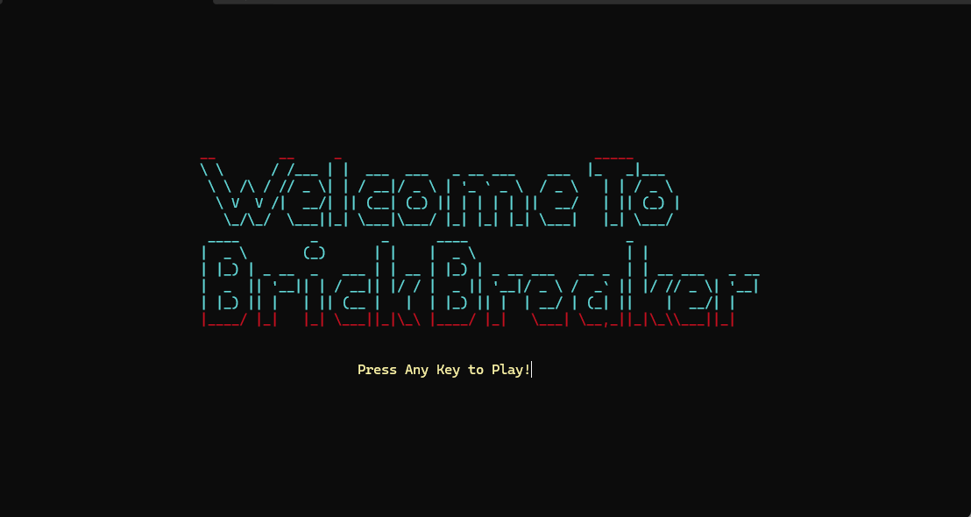

User Input: (name)
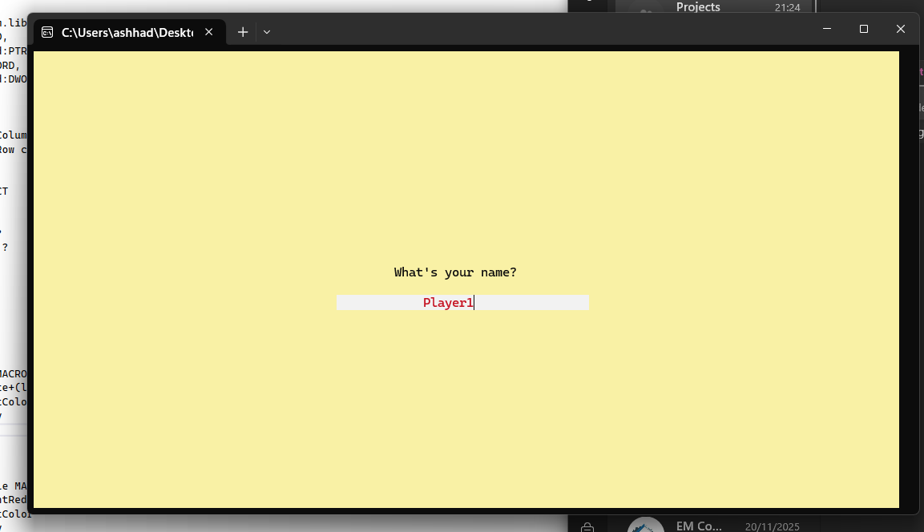

Main Menu:

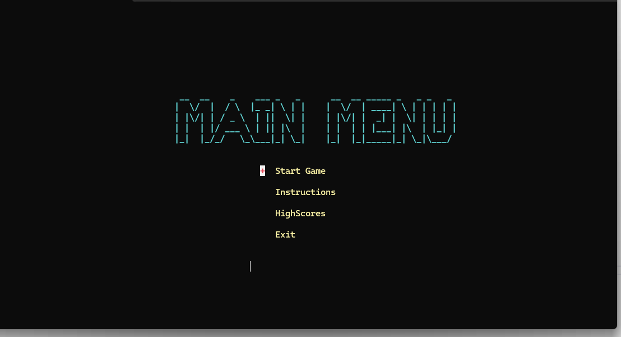

Difficulty Screen: (3 Modes Varying with ball speed)
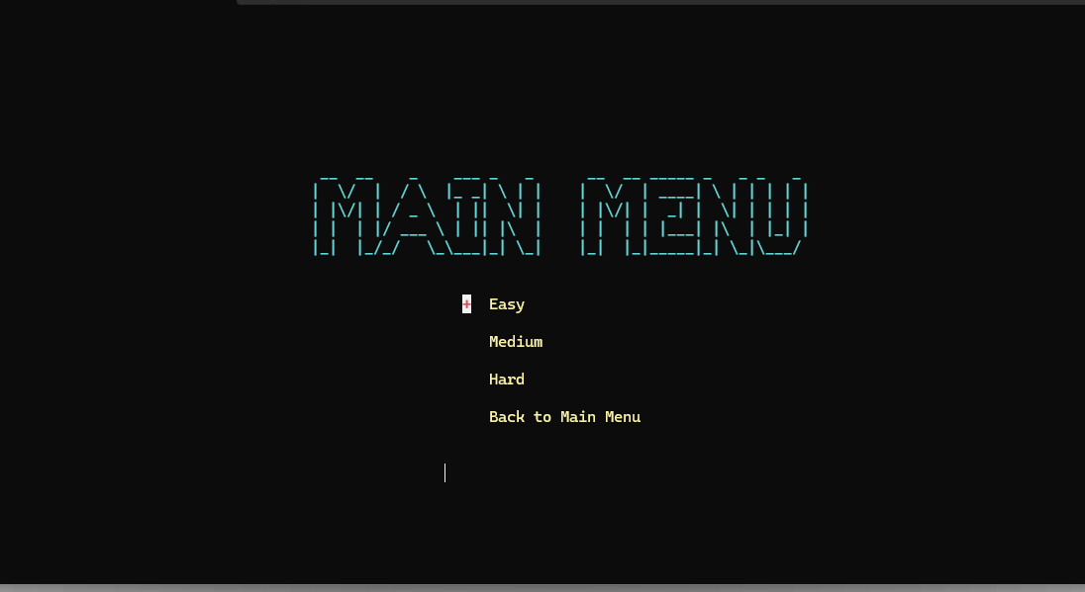

Game Screen:
Pressing S pauses/resumes screen
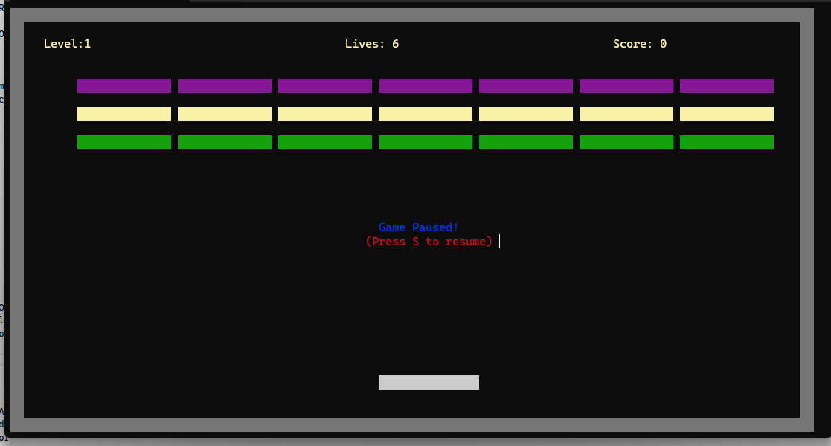

A levelCleared Box upon completion of level

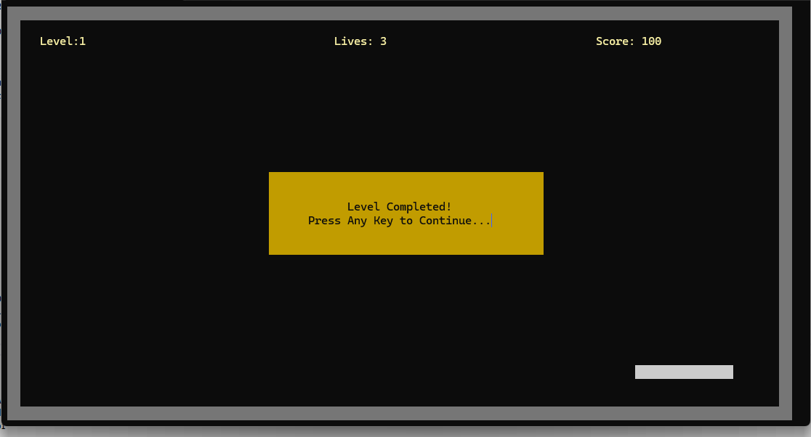

GameOver Screen: (Lives=0)

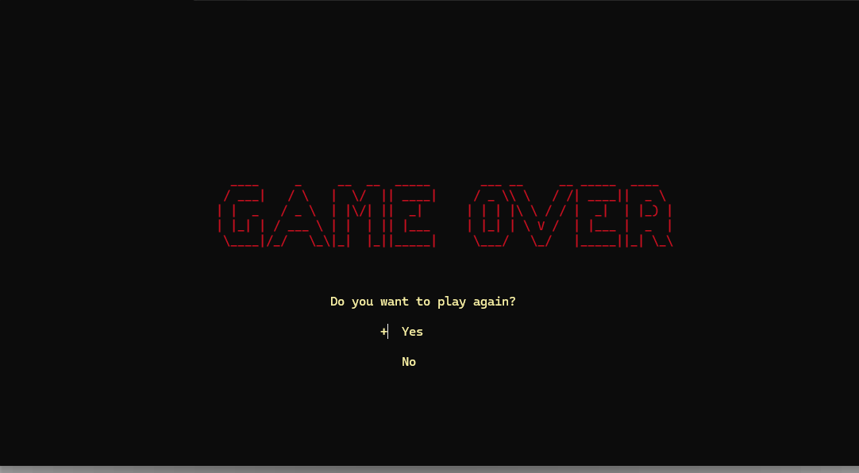

If All levels cleared, then winningScreen:

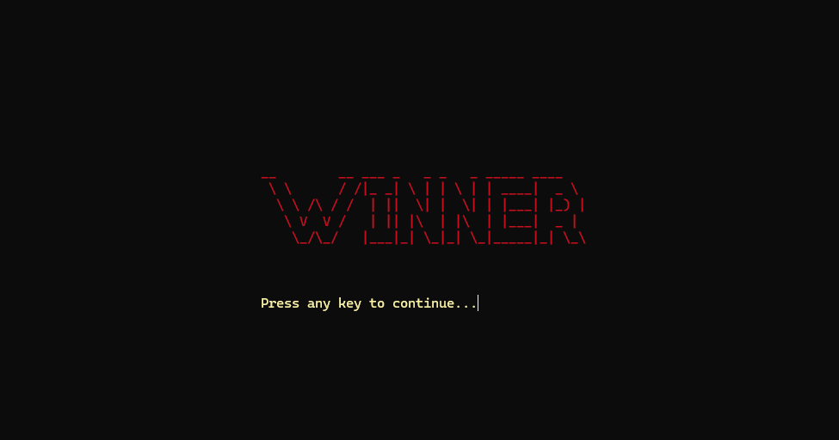

- Testing & Validation:

With addition of every new functionality, we made sure to evaluate it first before moving forward to another. Firstly,the main menu was evaluated, then the paddle and bricks display was assessed onwards the entire logic by playing the game with every test case: Such as for losing lives, for winning the game and everything else. For each level, we evaluated the game repeatedly to make sure there wasn’t any error. We also assessed If the game loop was working properly or not. Testing for the x and y coordinates was also part of our project.

At the end, the final testing included all the features of our game.

Conclusion:
- Summary of Findings:
Our project is proof that using assembly & its concepts, such projects can be implemented with console only.
Although, it sometimes becomes difficult to work with limited memory registers, syntax limitations, memory management in low level programming but still it is possible to implement real-time applications with multi-media integration in Assembly.

With further enhancements, this and similar to this many other projects in assembly can stand out among other projects which are made in high level languages. While high level languages are easier to implement, low level languages provide us a deeper understanding of how memory management of computers really works.

- Final Remarks:
Developing this game in Assembly exceeded our expectations which is a testament to the capabilities of low-level programming.

In Future, addition of other features can enhance this project which may include Save/Load Feature, Live Scoreboard, Infinite levels, Special Bricks and much more.

